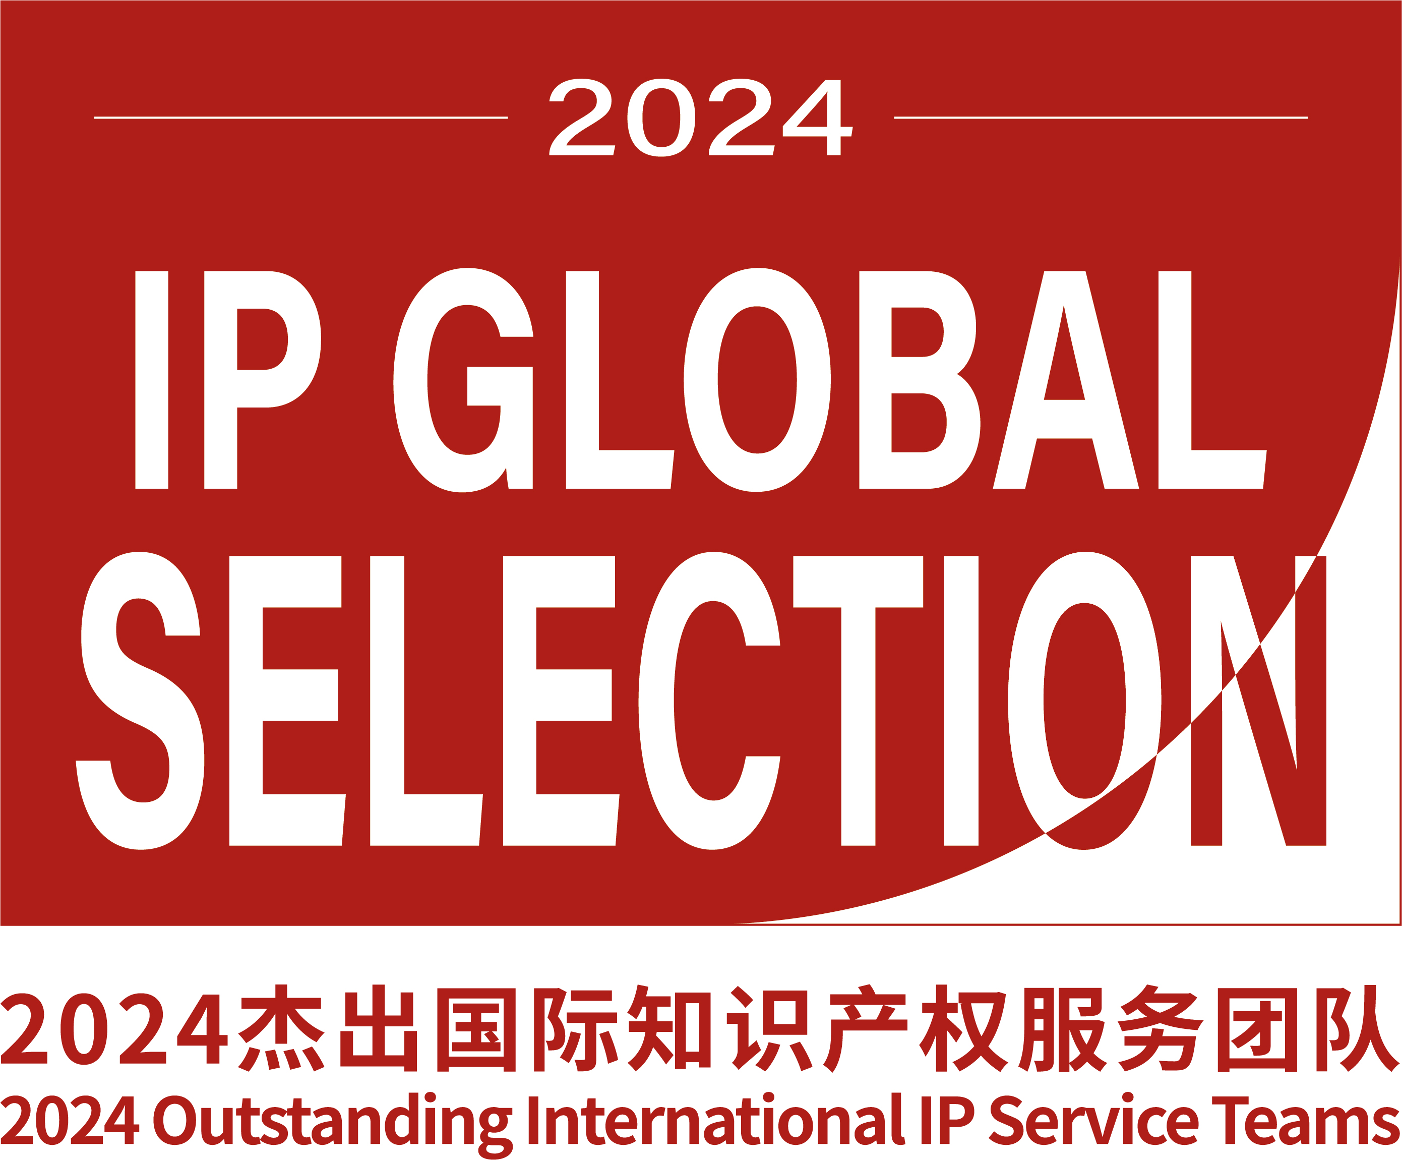

Application Form for
2024 Outstanding International IP Service Teams
Guidelines:
1. Submission deadline: November 30, 2024.
2. The selection is based on work or projects led by the team from January 1, 2023, to August 31, 2024.
3. This application form consists of five parts: Basics, Practice Facts and Statistics, Work Highlights, Team or Individual Awards and Accolades, and Partner Firms.
4. All information provided in this form must be accurate and truthful. If any information is found to be false, the host reserves the right to revoke the winner’s position.
5. You may add extra space within the form as needed.

Benefits:
- Present your team zero-distance to the most valuable customers and partners in China.
- Distinguish your team from competitors.
- Strengthen your customer trust in China and globally.
- A two-page company profile featured in the handbook for the 2025 Enterprise IP Strategy Forum & Annual Conference of In-house IP Managers.
- Inclusion in promotional activities across all of the host’s online and offline channels following the announcement of the final list.

Confidentiality clarification:
- Unless confirmed with the survey participant, the organizer will not disclose any information provided in this form to third parties.
- Selecting the checkbox in the table means you agree to have this information displayed in the conference handbook when your team has been included in the final list. If the box is not checked, the information will remain confidential.

For any help and suggestions please contact:
Jane Jiang (Ms.)
Email: jane.jiang@chinaiptoday.cn
Tel: +86 10 6515 8896
WeChat: 18911449529

Section I: Basics
 | Globally |  | China-based
Team/Firm’s name | ¨ |  | ¨
Year of establishment | ¨
Headquartered in ¨
Branch’s location | (i.e. London, New York...)
Number of employees ¨
Number of IP litigators
Number of patent practitioners | (including patent agent, engineer, litigator, consultant...)
Number of trademark practitioners
Number of other IP-related practitioners | (including copyright, trade secret, antitrust...)
Number of Chinese-speaking patent practitioners
Number of Chinese-speaking trademark practitioners
Number of Chinese-speaking other IP-related practitioners
Agency’s profile( within 300 words) ¨
Website
Section II: Practice Facts and Statistics
 | Globally |  | China-based
Best practice area(s) ¨ | (i.e. patent litigation...)  1  2  3  ... |  | 1  2  3  ...
Best industry sector(s) ¨ | (i.e. telecommunications...)  1  2  3  ... |  | 1  2  3  ...
Key clients ¨ | 1  2  3  4  5  ... |  | 1  2  3  4  5  ...
Number of Chinese clients ¨
Number of cases for Chinese clients (including cases involving China-based companies, their overseas subsidiaries.) ¨
Section III: Work Highlights
 | Globally |  | China-based
Note 1. Disclosure of monetary details is preferred but not required.
Note 2. In cases of litigation or dispute resolution, the plaintiff, defendant, the party represented by the firm, case no., and case summary are required. In cases of IP-related consulting cases, the information of clients and services is required.
Representative case illustrating (1)

¨
Representative case illustrating (2)

¨
Representative case illustrating (3)

¨
...
Section Ⅳ: Team or Individual Awards and Accolades ¨
Team:  1  2  3  4  5  ... |  | Individuals(with their names and positions):  1  2  3  4  5  ...
SectionⅤ: Partner Firms
 | Globally |  | China-based
Please list at least five firms you are partnering or have partnered within two years | 1  2  3  4  5  ... |  | 1  2  3  4  5  ...

